Connecticut Working Families Organization
30 Arbor Street, Hartford, CT 06106
Workingfamilies.org/Connecticut
(860) 523-1699

July 20, 2015

Dear Karen Humes,

On behalf of Connecticut Working Families, I submit this comment in response to the Census Bureau’s federal register notice regarding the Residence Rule and Residence Situations, 80 FR 28950 (May 20, 2015). I urge you to count incarcerated people at their home address, rather than at the particular facility that they happen to be located at on Census day.

Working Families organizes for social, economic and racial justice. We have historically advocated for laws and policies that improve the quality of life of workers and their families. Our model is centered on building power within communities by engaging all people in the political process. We firmly believe in political participation, both at the polls and at the General Assembly.

As you know, American demographics and living situations have changed drastically in the 225 years since the first Census, and the Census has evolved in response to many of these changes in order to continue to provide an accurate picture of the nation. Today, the growth in the prison population requires the Census to update its methodology again.

The need for change in the “usual residence” rule, as it relates to incarcerated persons, has been growing over the last few decades. As recently as the 1980s, the incarcerated population in the U.S. totaled less than half a million. But since then, the number of incarcerated people as more than quadrupled, to over two million people behind bars. The manner in which this population is counted now has huge implications for the accuracy of the Census.

By designating a prison cell as a residence in the 2010 Census, the Census Bureau concentrated a population that is disproportionately male, urban, and African-American or Latino into just 5,393 Census blocks that are located far from the actual homes of incarcerated people. In Connecticut, while Black individuals make up only 10% of the population, they make up 41% of the incarcerated population. Similarly, Latino individuals make up 13% of the total population but represent 29% of the incarcerated population. The practice of counting a prison cell as a residence has undoubtedly removed power from urban communities of color to mostly white suburban areas. In our state, the vast majority of the prison population was concentrated in 5 small towns, whose residents are mostly white. These towns have been able to count thousands of African Americans and Latinos as their own residents, even though these individuals were housed there only temporarily, and sentenced to those particular facilities for reasons that are frequently arbitrary.

We believe that the practice of counting incarcerated people as residents of the area in which they are housed compromises the democratic process. Those areas that house prisons add to their population count and thus their political clout. Larger districts are drawn thereby increasing the power of not only those that are elected but those who live near these prisons. But incarcerated people see no direct benefit for the usurpation of their political power.

This must change and it can start with the Census reforming its approach.

Thank you for this opportunity to comment on the Residence Rule and Residence Situations as the Bureau strives to count everyone in the right place in keeping with changes in society and population realities. Because Working Families believes in a population count that accurately represents communities, we urge you to count incarcerated people as residents of their home address.

Sincerely,
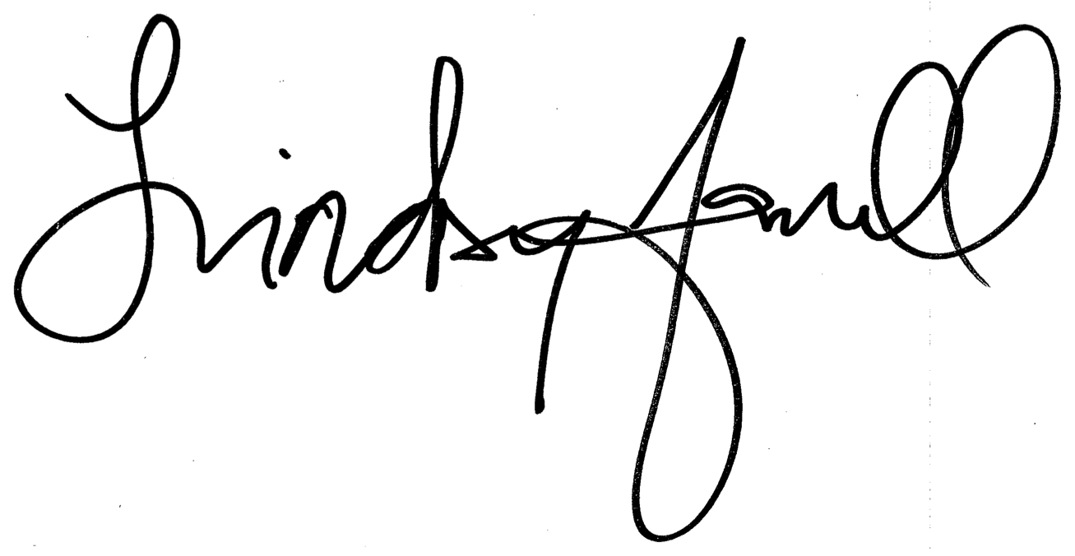
Lindsay Farrell
Executive Director

